Persian Classical Music

Cincinnati Persian Traditional Music Ensemble
@
Greaves Concert Hall
Northern Kentucky University

Musicians

Mehdy Behdad Ney
Ali Elmi Tombak
Negar Elmi Vocalist
Freidoon Ghazi Violin & Director
Nader Husseinzadeh Piano & Accordion
Siavash Mostajabi Tombak & Daf
Azadeh Namakydoust Tar
Babak Pazooki Tar & Setar
Ali Razavi Vocalist

Time and Date: 8:00 P.M., Saturday October 22, 2005

Place: Greaves Concert Hall

Tickets: $12 General Admission before October 15
$15 General Admission after October 15 and at the door

This event is general admission with open seating. Doors will open at 7:30 pm and concert will begin promptly at 8:00 pm

Purchase Tickets: Please make checks or money order payable to Cincinnati Persian Traditional Music Ensemble (CPTME) and mail to:

Sourushe Zandvakili
7305 DeMar Road
Cincinnati, OH 45243

Please do not send cash or your credit card number!
Questions call: (513) 556-2629 or Email: Sourushe.Zandvakili@UC.Edu
Attendance of small children is discouraged!

Northern Kentucky University Campus Map
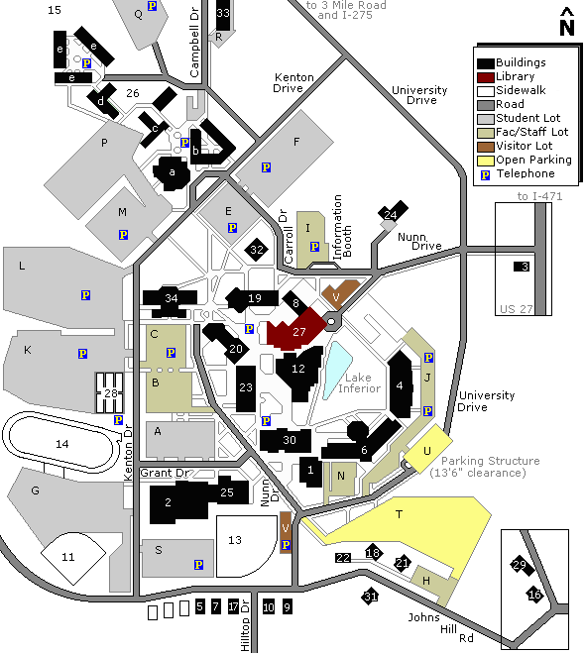Directions to Northern Kentucky University Campus
From Louisville, Lexington and Dayton:
- I-75 (North or South) to I-275 East
- Take Exit 76, “Three Mile Road/Northern Kentucky University”
- Turn right in to Nunn Drive (second traffic light)
- Greaves Concert Hall is in building #12, as shown on the campus map
From Columbus:
- I-71 South to I-471 South, Newport, Kentucky
- Go south to traffic light at the intersection of I-471 and U.S. Highway 27
- Continue straight and turn right at the next traffic light onto Nunn Drive
- Greaves Concert Hall is in building #12, as shown on the campus map

